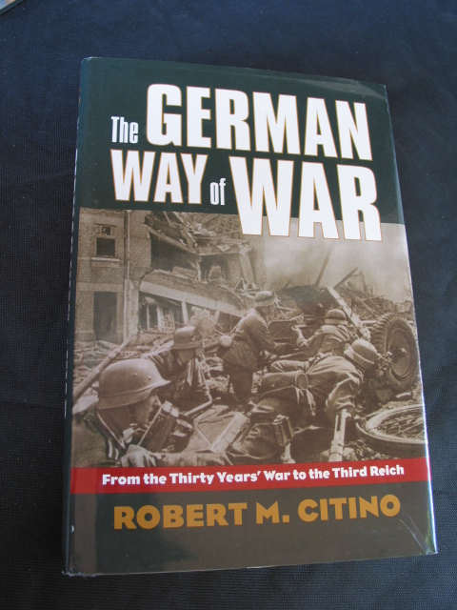
The German Way of WAR

Ship From:

Alan Blank

1835 caddington Dr. #38
Rancho Palos Verdes, CA 90275 / US

Ship To:

Wolfgang Schoenfeld
Box 224

3610 W. 2nd Ave.
MANSFIELD, GA 30055

MOJ

Ship From:

Alan Blank

1835 caddington Dr. #38
Rancho Palos Verdes, CA 90275 / US

Ship To:

David Spitzer
6424 se 77th ave
Portland, OR 97206

AR15 Charging Handle & Assembly

Ship From:

Alan Blank

1835 caddington Dr. #38
Rancho Palos Verdes, CA 90275 / US

Ship To:

Matt Taylor
4300 Eldorado Dr.
Plano, TX 75093

2 Vintage Watches, John Weitz & Time LTD. Glass Back

Ship From:

Alan Blank

1835 caddington Dr. #38
Rancho Palos Verdes, CA 90275 / US

Ship To:

danny doty
rt 2 box 218
comanche, OK 73529

Troy oz. Ingot

Ship From:

Alan Blank

1835 caddington Dr. #38
Rancho Palos Verdes, CA 90275 / US

Ship To:

David Jacobson
3316 Viewcrest Dr
Burbank, CA 91504

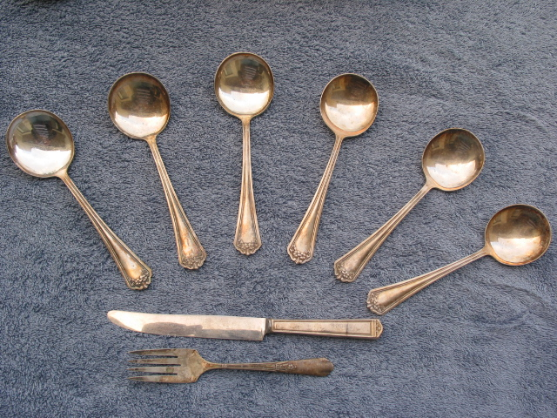

Antique Rogers Silver Flatware 6 Spoons, fork & Knife

Ship From:

Alan Blank

1835 caddington Dr. #38
Rancho Palos Verdes, CA 90275 / US

Ship To:

Robert C. / Lana L. Hendricks
15565 Zodiac St. NE
Forest Lake, MN 55025

2 Signed Photos Jo Anne Worley 1960s

Ship From:

Alan Blank

1835 caddington Dr. #38
Rancho Palos Verdes, CA 90275 / US

Ship To:

DEREK JENKINS
61 Rugby Road
Kingsbury, London
NW9 9LA
United Kingdom

1960s Western Airline uniform

Ship From:

Alan Blank

1835 caddington Dr. #38
Rancho Palos Verdes, CA 90275 / US

Ship To:

brien dippi
16445 Shelby St
Choctaw, OK 73020

1876 Belgium Leopold
1882 GREECE 10 LEPTA

Ship From:

Alan Blank

1835 caddington Dr. #38
Rancho Palos Verdes, CA 90275 / US

Ship To:

Jeff Williams
525 3RD ST E
WESTHOPE, ND 58793-4100

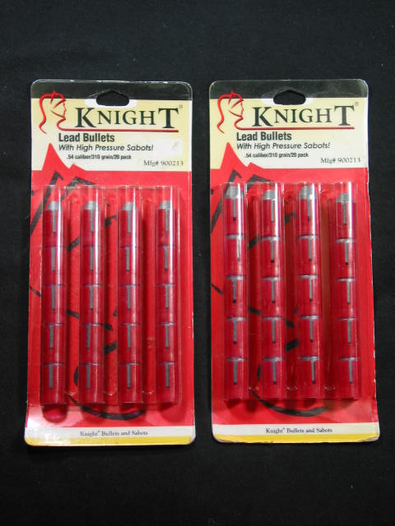

2 Knight .54, / 900213 / 40

Ship From:

Alan Blank

1835 caddington Dr. #38
Rancho Palos Verdes, CA 90275 / US

Ship To:

Richard Finke
400 W JUNIPER AVE
WAKE FOREST, NC 27587-2318

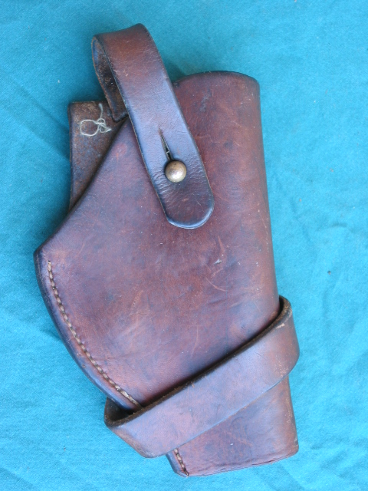

Vintage 1957 Small Revolver Back-up Holster

Ship From:

Alan Blank

1835 caddington Dr. #38
Rancho Palos Verdes, CA 90275 / US

Ship To:

Mike Walker
2615 YH HANSON AVE
ALBERT LEA, MN 56007-3422

WWII 1943 Conventional Signs, Military Symbols

Ship From:

Alan Blank

1835 caddington Dr. #38
Rancho Palos Verdes, CA 90275 / US

Ship To:

John Runion, Sr.
11614 PRIMWOOD DR
HOUSTON, TX 77070-2536

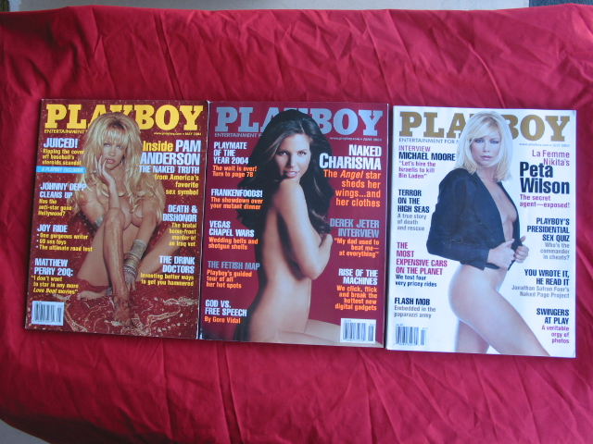

3 Playboy Magazines 2004, May, June, July

Ship From:

Alan Blank

1835 caddington Dr. #38
Rancho Palos Verdes, CA 90275 / US

Ship To:

William Forsythe
4762 W PIUTE AVE
GLENDALE, AZ 85308-5152

1934 Empress of Britain / Canadian Pacific Letter, Rare

Ship From:

Alan Blank

1835 caddington Dr. #38
Rancho Palos Verdes, CA 90275 / US

Ship To:

Fella F. Livermore
4805 Sorrento CT Unit 4
Cape Coral, FL 33904

1934 Empress of Britain / Canadian Pacific Letter, Rare

Ship From:

Alan Blank

1835 caddington Dr. #38
Rancho Palos Verdes, CA 90275 / US

Ship To:

Fella F. Livermore
4805 Sorrento CT Unit 4
Cape Coral, FL 33904

1934 Empress of Britain / Canadian Pacific Letter, Rare

Ship From:

Alan Blank

1835 caddington Dr. #38
Rancho Palos Verdes, CA 90275 / US

Ship To:

Fella F. Livermore
4805 Sorrento CT Unit 4
Cape Coral, FL 33904

1934 Empress of Britain / Canadian Pacific Letter, Rare

Ship From:

Alan Blank

1835 caddington Dr. #38
Rancho Palos Verdes, CA 90275 / US

Ship To:

Fella F. Livermore
4805 Sorrento CT Unit 4
Cape Coral, FL 33904

1934 Empress of Britain / Canadian Pacific Letter, Rare

Ship From:

Alan Blank

1835 caddington Dr. #38
Rancho Palos Verdes, CA 90275 / US

Ship To:

Fella F. Livermore
4805 Sorrento CT Unit 4
Cape Coral, FL 33904

1934 Empress of Britain / Canadian Pacific Letter, Rare

Ship From:

Alan Blank

1835 caddington Dr. #38
Rancho Palos Verdes, CA 90275 / US

Ship To:

Fella F. Livermore
4805 Sorrento CT Unit 4
Cape Coral, FL 33904

1934 Empress of Britain / Canadian Pacific Letter, Rare

Ship From:

Alan Blank

1835 caddington Dr. #38
Rancho Palos Verdes, CA 90275 / US

Ship To:

Fella F. Livermore
4805 Sorrento CT Unit 4
Cape Coral, FL 33904

1934 Empress of Britain / Canadian Pacific Letter, Rare

Ship From:

Alan Blank

1835 caddington Dr. #38
Rancho Palos Verdes, CA 90275 / US

Ship To:

Fella F. Livermore
4805 Sorrento CT Unit 4
Cape Coral, FL 33904

1934 Empress of Britain / Canadian Pacific Letter, Rare

Ship From:

Alan Blank

1835 caddington Dr. #38
Rancho Palos Verdes, CA 90275 / US

Ship To:

Fella F. Livermore
4805 Sorrento CT Unit 4
Cape Coral, FL 33904

1934 Empress of Britain / Canadian Pacific Letter, Rare

Ship From:

Alan Blank

1835 caddington Dr. #38
Rancho Palos Verdes, CA 90275 / US

Ship To:

Fella F. Livermore
4805 Sorrento CT Unit 4
Cape Coral, FL 33904

